15th Munich Muscle Meeting
Hybrid at BMC and online via Zoom
Date: 30th June 2022
Time: 16:00-18:00 h
Informal Extra Session: 18-19:00 h

Dear Munich Muscle Researchers & Guests,

The next Munich Muscle Meeting (MMM) will be held in a hybrid format because of the stable COVID-19 situation. The upcoming meeting is being organized by Maria Spletter, who will host the in-person session at the Department of Physiological Chemistry (Biomedical Center Martinsried, LMU, Room N01.017). In addition, we will use Zoom to broadcast the meeting online, because we also have international guests who will not be on the spot in Munich.

We are happy to welcome our keynote speaker on muscle physiology:
Dr. Karyn Esser from the University of Florida, talking on “The muscle clock and exercise: transcriptional partners?”

We will additionally have a talk by Dr. Anthony Hessel on residual force enhancement using typical mechanics followed by talks from Sophie Franzmeier on satellite cell function in DMD and Elena Nikonova on Bruno function in mRNA splicing in the muscle of the fly.
How to register for the Meeting and Zoom access to MMM?

Browser registration:
Please use the following Zoom-Link to register online for the 15th Munich Muscle meeting, even if you participate in presence.

https://tum-conf.zoom.us/meeting/register/u5IrdOypqzMrG9HXqNYjY6X8odoFRWm0GWIY

After you have registered with your name and email address, you will get an automated confirmation by mail including all information to participate.

Meeting guidelines

During the talks, please switch off your microphone and camera. After each talk we have reserved 5 minutes for questions and discussion.
You can either ask a question or submit questions via the chat function during the talks.

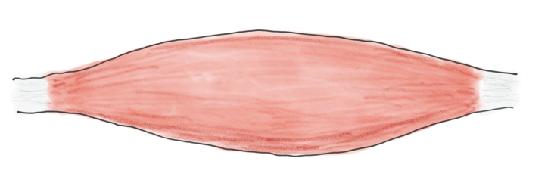

Contact address

Maria Spletter, Ph.D.
Biomedical Center, N.B 02.015
Dept. of Physiological Chemistry
Ludwig-Maximilians-Universität München
Großhaderner Str. 9
82152 Martinsried Germany
+49 89 2180 77128
maria.spletter@bmc.med.lmu.de

Web www.en.bmc.med.uni-muenchen.de/index.html

Want to be added to the MMM list?

Please register for the meeting list using the mailman app.
What is the Munich Muscle Meeting?
The Munich Muscle Meeting is organised by Munich-based muscle research groups. The aim is to present muscle research and to initiate collaborative projects.
Programme
Moderation: Dr. Maria Spletter
16.00 - 16.05: Dr. Maria Spletter
(Dept. of Physiological Chemistry, LMU) Welcome
Scientific talks
16.05 – 17:00: Dr. Karyn Esser (University of Florida) "The muscle clock and exercise: transcriptional partners?"
17:00 – 17:30: Dr. Anthony Hessel (University of Münster) “Sarcomeres with controllable titin cleavage present no evidence of enhanced force production after an eccentric stretch.”
17:30 - 17.45: Sophie Franzmeier (Schlegel Lab, Institute of Pathology, TUM School of Medicine)
”Satellite Cells in DMD”
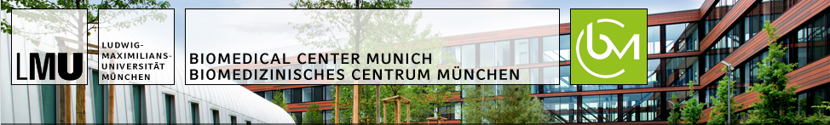
17.45 – 18:00: Elena Nikonova (Spletter Group, Biomedical Center, LMU)
“Bruno1 function is required for proper formation and maturation of Drosophila flight muscle”
18:05 - 18.10: Dr. Maria Spletter
(Dept. of Physiological Chemistry, LMU):
Closing remarks and organisation next meeting

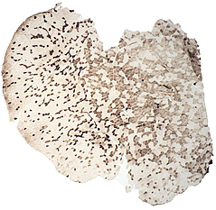

18:10 – 19:00: Informal Science/Career Session with Dr. Karyn Esser. Opportunity for anyone interested (especially students and postdocs) to have a discussion on topics ranging from science to career to work-life balance with our accomplished keynote speaker.

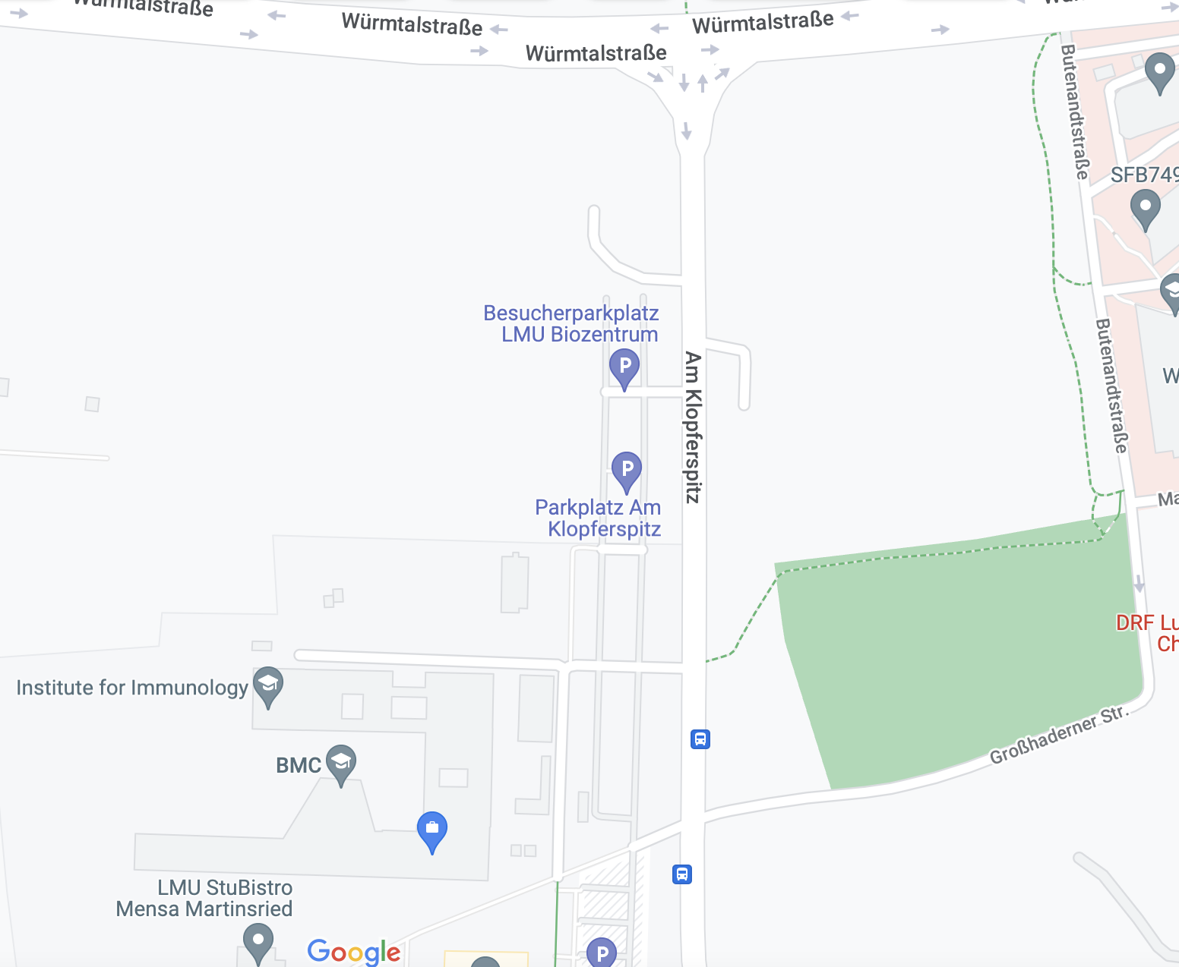
Meeting location for in person participants
Address:
Biomedical Center, LMU
Großhaderner Str. 9
82152 Martinsried-Planegg

Room:
N01.017
Travel Directions:
Parking
By Public Transport
Bus 266, LMU Martinsried. From the city center, take U6 to Klinikum Großhadern, then take Bus 266 to LMU Martinsried. The BMC is also a short 10-minute walk from Klinikum Großhadern.

By Car
BMC
If you are arriving by car, take Wurmtal Straße to Am Klopferspitz. Parking is free in the lots on the right side of the street in front of the BMC.
N01.017
Bus 266
LMU Martinsried

